Rudra Chinhara

Program to show that the effect of default arguments can be alternatively achieved by overloading.
Assignment-4

CODE
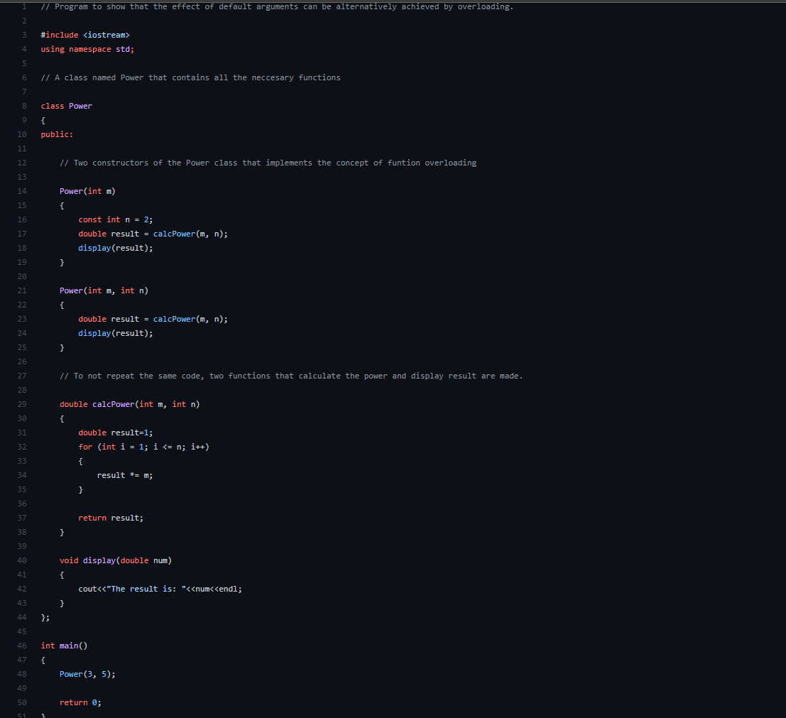
OUTPUT

Github Link

